Page 1
Single buy - vPOS 2.0
1. Introduction
The following document presents the technical information necessary to communicate with the eCommerce payment gateway service of Bancard or VPOS.

The product to be built by the commerce may be Web or Mobile. Below are the different interactions with API services REST as well as necessary redirections to a Bancard interface to request the credit card information.
In addition to this document, the commerce or developer of the integration with VPOS must have access to the commerce portal of Bancard: https://comercios.bancard.com.py
In it you will be given access to:
- Access to the staging and production of vpos
- Access the public and private key. Additionally you can regenerate both keys.
- Modify profile information: Name, logo and confirmation url
- Trace of interactions between VPOS and the product developed by the commerce.
- Checklist with steps to validate the integration.
- Documentation and examples of codes in different languages.
Purchase flow
Below is the flow that the business must implement between its Web or Mobile product and VPOS.

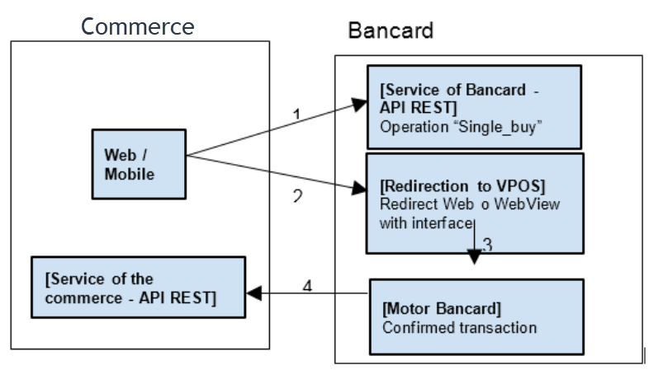

Operations
The Bancard eCommerce has three operations published as Web Services REST available for the associated businesses that

Page 2
they will allow a payment authorization, a rollback or cancellation, and obtain confirmation information.
The client must offer in a public URL and by common consent a service through which the approval or cancellation of the transaction of a final client, also to function as a Web Service client of vPOS should support TLS1.2 ..

Services offered by VPOS
- single_buy - start the payment process.
- single_buy_rollback - operation that allows you to cancel the payment.
- get_single_buy_confirmation - operation that informs if a payment was confirmed or not.
Services offered by the commerce
- single_buy_confirm - operation that will be invoked by VPOS to confirm a payment.

2- Authentication
The private and public key will allow identifying all interactions with the Bancard eCommerce services. These keys will be sent by the product developed by the commerce in all their requests to identify themselves (the private key never travel in plain text, but hashed with other information in the form of token). Both can be generated again in case of violation.

The public key will be unique, and in the form: [a-zA-Z0-9] {32}. The private key does not have to be unique (although it surely is), and in the form: [a-zA-Z0-9T1] {40}.

Requests made by the commerce to VPOS
The requests will be made by POST to a REST interface

public_key | Public key of the commerce.
operation | Data of the operation that is going to be carried out.

Page 3
{
"public_key": "[public key]",
"operation": {
"token": "[generated token]",
...
}
}

Token
The token will be generated at the moment of making the request, depending on the operation. It will always be an md5 (32 characters). The order must
be exactly as indicated.

single buy
md5 (private_key + shop_process_id + amount + currency)

single_buy confirm
md5 (private_key + shop_process_id + "confirm" + amount + currency)

single_buy get confirmation
md5 (private_key + shop_process_id + "get_confirmation")

single buy rollback
md5 (private_key + shop_process_id + "rollback" + "0.00")

The confirm token for a rollback action is generated using "0.00" for amount.

When generating the token, the numbers must be transformed into strings, use two decimal digits and a period (".") as a separator
of decimals. ex:

token = md5 ("[private key]" + "3332134" + "130.00" + "130.00")

3- Operations

Page 4
3.1 - Operations of infonet-vpos

3.1.1 - Single Buy

POST {environment} /vpos/api/0.3/single_buy

Environment
- Production - https://vpos.infonet.com.py
- Staging - https://vpos.infonet.com.py:8888

Operation invoked by the commerce to initiate the payment process.

The service will return a process identifier (process_id) temporarily generated by the VPOS server.

A Single Buy must be completed successfully to enable the corresponding option in the Test List -> Implementation of payments

The order will be composed of a JSON with the following elements:

Elements of the petition

public_key | Public key | String (50)
operation | Operation Element | Operation

Operation Elements

token | md5 of the request | String (32)
shop_process_id | identifier of the purchase. | Integer (15)
amount | Amount in Guaranies. | Decimal (15,2)  - decimal separator '.'
currency | Type of currency. | String (3)  - PYG (Gs)
additional_data | Reserved service field reserved for special cases. Optional | String (100)
description | Payment description, to show the user. | String (20)
return_url | URL where the user will be sent to make the payment. Keep in mind that if the card is rejected, it will also be redirected to this URL. | String (255)
cancel_url | URL where the user will be sent to cancel the payment. Optional, return_ will be used as default url. | String (255)

Page 5
Description of "additional_data"

This element will be used to send additional information to validate at the time of authorization of the purchase. It will be used to indicate promotions or agreements made between the commerce, Bancard and the issuer.

The structure of this element will be:
Data | Datatype | Format | Position | Scope | Example
Entity | Int (3) | Filled with zeros on the left | 1-3 | TC and TD (CC and DC) | 099
Brand | String (3) | Filled with spaces to the right | 4-6 | TC and TD (CC and DC) | 'VS'
Product | String (3) | Filled with spaces to the right | 7-9 | TC and TD (CC and DC) | 'ORO' (GOLD)
Affinity | Int (6) | Filled with zeros on the left | 10-15 | TC (CC) | 000045

Example of data to send if the commerce wants to validate that:

. the card is from a specific entity: 099
. the card is of a specific entity and affinity: 099 000045
. the card is from a specific entity and brand: 099VS
. the card is from an entity, brand and specific product: 099VS ORO
. the card is of a specific brand: 000VS

Request example:
{
"public_key": "[public key]",
"operation": {
"token": "[generated token]",
"shop_process_id": 54322,
"currency": "PYG",
"amount": "10330.00",
"additional_data": "099VS ORO000045",
"description": "Payment example",
"return_url": "http://www.example.com/finish"
"cancel_url": "http://www.example.com/cancel"
}
}

The response will consist of a JSON with the following elements:

status | Response status | String (20)
process_id | Purchase identifier | String (20)

Page 6
Example answer:

{
"status": "success",
"process_id": "i5fn * lx6niQel0QzWK1g"
}

Note:
"The response message will be sent in the body (body) of the HTTP request"

3.1.2 - Single Buy Rollback

POST {environment} /vpos/api/0.3/single_buy/rollback

Environment
- Production - https://vpos.infonet.com.py
- Staging - https://vpos.infonet.com.py:8888

The Rollback operation must be sent in the following cases:

- To make a reverse payment.
- For transactions canceled by the user on the vPos page.
- For transactions abandoned or not completed by the user.

The Rollback operation will be satisfactory as long as the transaction has not been COUPONED (confirmed in the client's statement). If the JSON returns status: error and key: "TransactionAlreadyConfirmed", the commerce must perform the manual process of reversion order of a transaction coupon to be processed in the Bancard Commercial Area.

The rollback will return a general status "status". "Success" indicates that the order will be notified to cancel. "Error" indicates that for some reason the order cannot continue. The possible causes of error are:

- InvalidJsonError - Error in the JSON sent
- UnauthorizedOperationError - Sent credentials do not have permission for the rollback operation.
- ApplicationNotFoundError - There are no permissions for the credentials sent.
- InvalidPublicKeyError - There is an error about the public key sent.
- InvalidTokenError - The token was generated incorrectly.
- InvalidOperationError - The JSON sent is not valid. Does not comply with defined types or limits.
- BuyNotFoundError - The selected purchase process does not exist
- PaymentNotFoundError - There is no payment order for the selected process. This means that the client did not pay for this requested and should be taken as a correct answer for such situations.
- AlreadyRollbackedError - A previous rollback request already exists.
- PosCommunicationError - There are communication problems with the rollback request component.
- TransactionAlreadyConfirmed - Coupon Transaction (Confirmed in the client's extract)

In case that a purchase is initiated by the product developed by the commerce but is not finalized by the user or there is no response from part of vpos after 10 minutes, you should invoke a Get Buy Single Confirmation to know the status of the order. If the payment has not yet been made, the commerce can choose to rollback the order invoking the Single Buy Rollback operation.

Page 7

Note:
A Single Buy Rollback manual must be successfully completed in an approved transaction case to enable the corresponding option in the Test list -> Receive rollback (Recibir rollback)

The order will consist of a JSON with the following elements:

Elements of the petition
public_key | Public key | String
operation | Operation Element | Element

Operation Element

token | md5 of the request | String
shop_process_id | Internal identifier of the commerce | String

Request example:
{
"public_key": "[public key]",
"operation": {
"token": "[generated token]",
"shop_process_id": "12313"
}
}

The response will consist of a JSON with the following elements:

Elements of the response

status | Response status | String  Possible values:  - success  - error
messages | Element Array Message | Array

Page 8

Message element

key | Answer key | String  Possible values:  - InvalidJsonError  - UnauthorizedOperationError  - ApplicationNotFoundError  - InvalidPublicKeyError  - InvalidTokenError  - InvalidOperationError  - BuyNotFoundError  - PaymentNotFoundError  - AlreadyRollbackedError  - PosCommunicationError  - RollbackSuccessful  - TransactionAlreadyConfirmed
level | Level of message display | String  Possible values:  - info  - error
dsc | Response description | String

Example answer:

{
"status": "success",
"messages": [
{
"key": "RollbackSuccessful",
"level": "info"
"dsc": "Rollback correcto.",
}
]
}

Page 9

3.2 - Confirmation operation to the commerce

3.2.1 - Buy Single Confirm

POST [URL] (Defined by commerce)

This action is invoked by VPOS at the end of a transaction. It aims to confirm or cancel a payment. This will be the only means by which the client will have the certainty that the
user successfully completed a transaction.

Bancard will make a POST request by sending the JSON in the body of the order or body.
The commerce must respond with status 200 to the operation, as shown below in the
response example. If the commerce does not respond with status 200 within the next 60 seconds, vPOS will close the connection and be marked as invalid the confirmation in the trace and with an indication of the timeout in replacement of what should have been the response of the commerce.

Note:
If the Web or Mobile product developed by the Commerce initiates the purchase operation (single buy) and does not receive the confirmation (single buy confirm) by the VPOS, you must invoke the reversal operation (single buy rollback) to avoid inconsistencies in your system. Suggested waiting time is of 10 minutes.
A Buy Single Confirm must be completed successfully to enable the corresponding option in the Test List -> Confirm correctly to the commerce.

The order will be composed of a JSON with the following elements:

Elements of the petition

operation | Operation element | Element

Operation Elements

token | md5 of the request | String (32)
shop_process_id | internal identifier of the commerce | Integer (15)
response | Detail indicator processed | String (1) - S or N
response_details | Process description | String (60)
amount | Amount in Guaranies | Decimal (15.2)  - decimal separator '.'
currency | Type of currency. | String (3)  - PYG (Gs)
authorization_number | Authorization code | String (6)  - Only if the transaction is approved.
ticket_number | Authorization identifier. | Int (15)
response_code | Response code of the transaction. | String (2)  - 00 (approved transaction)  - 05 (Card disabled)  - 12 (Invalid transaction)  - 15 (Invalid Card)  - 51 (Insufficient funds)
response_description | Description of the transaction response. | String (40)
extended_response_description | Extended description of the answer transaction. | String (100)
security_information | SecurityInformation Element | Element

Page 10

SecurityInformation Elements

card_source | Local or International | String (1)  - L (Local)  - I (International)
customer_ip | Ip of the customer who enters the payment information | String (15)
card_country | Country of origin of the card | String (30)
version | API Version | String (5)
risk_index | Risk indicator | Int (1)

Request example:

Page 11
{
"operation": {
"token": "[generated token]",
"shop_process_id": "12313",
"response": "S",
"response_details": "answer S",
"extended_response_description": "extended response",
"currency": "PYG",
"amount": "10100.00",
"authorization_number": "123456",
"ticket_number": "123456789123456",
"response_code": "00",
"response_description": "Transaction approved.",
"security_information": {
"customer_ip": "123.123.123.123",
"card_source": "I",
"card_country": "Croatia",
"version": "0.3",
"risk_index": "0"
}
}
}

Notes:
- The attribute of "risk_index" will be part of the response but a valid data will not be sent yet. Momentarily it will be represented with value "0".
- The JSON sent complies with the coding and encoding standards. See annex for more information.

Example answer:
{
"status": "success"
}

Page 12

3.3 - Operation to obtain confirmation

3.3.1 - Get Buy Single Confirmation

POST {environment} /vpos/api/0.3/single_buy/confirmations

This action is invoked by the commerce to consult whether or not there was a confirmation.

A Buy Buy Single Confirm must be completed successfully to enable the corresponding option in the Test List -> Consulted Confirmation correctly.

The order will be composed of a JSON with the following elements:

Elements of the petition

public_key | Public key | String (50)
operation | Operation Element | Operation

Operation Elements

token | md5 of the request | String (32)
shop_process_id | identifier of the purchase. | Integer (15)

The response will consist of a JSON with the following elements:

Elements of the response

status | Response status | String  Possible values:  - success  - error
confirmation | Confirmation information | SingleBuyConfirmation element
messages | Element Array Message | Array

Page 13
Message element

key | Answer key | String  Possible values:  - InvalidJsonError  - UnauthorizedOperationError  - ApplicationNotFoundError  - BuyNotFoundError  - InvalidPublicKeyError  - InvalidTokenError  - InvalidOperationError  - PaymentNotFoundError  - AlreadyRollbackedError
level | Level of message display | String  Possible values:  - info  - error
dsc | Response description | String

SingleBuyConfirmation element

token | MD5 of the request | String (32)
shop_process_id | Internal identifier of the commerce | Integer (15)
response | Detail indicator processed | String (1) - S or N
response_details | Process description | String (60)
amount | Amount in Guaranies. | Decimal (15.2)  - decimal separator '.'
currency | Type of currency. | String (3)  - PYG (Gs)
authorization_number | Authorization code | String (6)  - Only if the transaction is approved.
ticket_number | Authorization identifier. | Int (15)
response_code | Response code of the transaction. | String (2)  - 00 (approved transaction)  - 05 (Card disabled)  - 12 (Invalid transaction)  - 15 (Invalid Card)  - 51 (Insufficient funds)
response_description | Description of the transaction response. | String (40)
extended_response_description | Extended description of the transaction answer. | String (100)
security_information | SecurityInformation Element | Element

Page 14
SecurityInformation Elements

card_source | Local or International | String (1)  - L (Local)  - I (International)
customer_ip | Ip of the customer who enters the payment information | String (15)
card_country | Country of origin of the card | String (30)
version | API Version | String (5)
risk_index | Risk indicator | Int (1)

Request example:

{
"public_key": "[public key]",
"operation": {
"token": "[generated token]",
"shop_process_id": "12313"
}
}

Example answer:

Page 15
{
"status": "success"
"confirmation": {
"token": "[generated token]",
"shop_process_id": "12313",
"response": "S",
"response_details": "answer S",
"extended_response_description": "extended response",
"currency": "PYG",
"amount": "10100.00",
"authorization_number": "123456",
"ticket_number": "123456789123456",
"response_code": "00",
"response_description": "Transaction approved.",
"security_information": {
"customer_ip": "123.123.123.123",
"card_source": "I",
"card_country": "Croatia",
"version": "0.3",
"risk_index": "0"
}
}
}

Notes:
- The attribute of "risk_index" will be part of the response but a valid data will not be sent yet. Momentarily it will be represented with the value "0".
- The JSON sent complies with the coding and encoding standards. See annex for more information.

4- Redirection to the VPOS service

GET {environment} / payment / single_buy

Page 16

Environment
- Production - https://vpos.infonet.com.py
- Staging - https://vpos.infonet.com.py:8888

After calling the action "single_buy", the product of the commerce must redirect the user to VPOS.

Parameters

process_id | Identifier returned by the action "single_buy"
from_mobile | A Boolean value that indicates whether the interface to be loaded must be optimized to be viewed on a mobile device or not (Optional parameter for mobile application implementations).

example:

https://vpos.infonet.com.py/payment/single_buy?process_id=1veY2NMX3Od751Lu0sK5& from_mobile= true

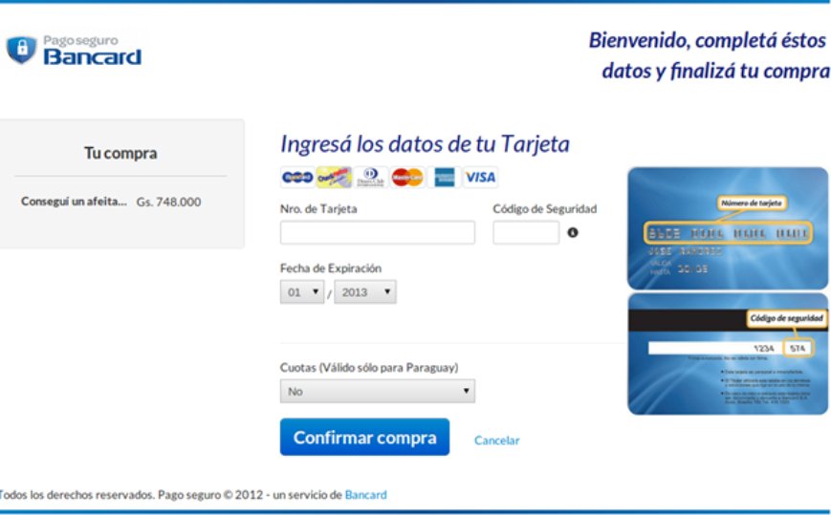

4.1- Web redirection - user payment

If the product built by the commerce is with Web interface, you must redirect to the url using a redirect.

When making this request the VPOS service will detail the information of the sale: text and amount as well as a form to allow the user to enter his credit card information.

Next, the Web screen that the end user would see is displayed.

Page 17

4.2- Mobile redirection - user payment

If the product built by the commerce is Mobile (Android, iOS or any code generation or interpretation framework) it must make a request to the url (the url for the mobile application is the same as the web implementation) embedding the content in a WebView or Web component within the application.

Once the client enters the card information, the WebView component must be closed and continue with the application flow to visualize the result of the transaction.

In the commerce portal a series of code examples is shared and particularly a reference to a base project in Android for implementing a primary flow. You can see and download the code: https://github.com/Bancard/vpos-android
Next, a Mobile screen is displayed with the result of invoking the url within a WebView.

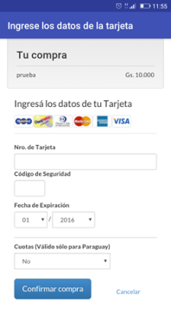

4.3- Payment through iframe of checkout

Once the process_id has been obtained, the user will be able to include an embedded checkout form in his e-commerce, in this way the purchase may end up in your own application. For this you can use the JavaScript library as indicated in the following
code repository.

5- The commerce restrictions

Below are restrictions that must be considered by the commerce that develops the integration with the Bancard eCommerce.

Response interface

After the user enters their card data and confirms to the commerce through the operation "Buy Single Confirm" the commerce must deploy a response interface with the approval of the transaction.

In this interface the following restrictions must be respected:
- The details of the transaction must be indicated:
Date and Time

Page 18
Order number (shop_process_id)
Amount (amount)
Description of the Response (response_description)

- The user should not be shown:
Authorization code (authorization_number)
Response code (response_code)
Extended response (extended_response_description)
Security information (security_information)

General notes

- The Commerce must include in its application the section of Contact, so that the client can evacuate queries regarding the ecommerce purchases.
- The application may register all customer data required by the commerce, except for all those related to your credit cards.(Card number, security code, expiration, etc.)
- The logo to be used by the commerce should ideally have a width of 173 pixels and a high 55 pixels. The minimum width is 85 pixels.

Messaging format – JSON

The JSON (JavaScript Object Notation) format will be used to send and receive information.

Information about JSON - http://json.org/

JSON validation - http://jsonlint.com/

When consuming a JSON sent by the VPOS, special attention must be paid to special characters (eg accents). It will be sent using the standard "\ uXXXX" (where X is a hexadecimal digit)

The JSONs sent and received by Bancard and the commerce must be made through a POST request by sending the JSON in the body of the order or body.

Monitoring

In order to meet our quality standards, the customer service will be monitored to analyze the uptime.

Every 5 minutes a post request will be made to the confirmation URL with an empty JSON data.

